***THE ENGINEERING METHOD***

**Context:**

The coffee park board has reached us asking for a software for the park. The software consists on a map that let the users trace the best route to get to certain attractions in a specific times.

**Problem developing**

In order to solve the situation we were faced, we decided to use the engineering method to focus on a systematic view that match with the problem.

Following the steps of the engineering method from the book “introduction to engineering” from Paul Wright, we defined the next diagram which describe the steps we are going to use in the process.

**Problem identification**

The coffee park has become a huge attraction in Colombia for its tradition and its unique attractions, people around the world travel to experience a day in it. Because of that, the park so often gets extremely crowded and become hard to move around and the wait lines are unbearable. Having that in mind, the software we are going to develop it’s focused on making easier for the people to go to their favourite attractions easily and in the shortest time.

*Sympthoms and necesities:*

* The software has to be able to let the users choose the attractions they want to visit
* The Attractions have to be shown in the map to choose them
* The program has to be able to manage big amounts of data

*Problem definition:*

The problem requires to develop a software that let the user manage the attractions they want to visit and the time they spend in the process, letting the user choose the best one for they experience int the coffee park

**Data recompilation**

In order to create a solution for the problem we are faced, we have to analyse the process of organizing statistics in a data base and sorting them by categories. Following next, there are the concepts we searched about to be able to solve the problem correctly

**Generics:**

[1]Generics mean parameterized types. The idea is to allow type to be a parameter to methods, classes, and interfaces. Using Generics, it is possible to create classes that work with different data types. An entity such as class, interface, or method that operates on a parameterized type is called a generic entity.

**Github:**

[2]GitHub is one of the world’s largest community of developers. It’s an intricate platform that fosters collaboration and communication between developers. GitHub has several useful features that enable development teams to work together on the same project and easily create new versions of software without disrupting the current versions

**Binary Search Trees:**

[3]An AVL tree is another balanced binary search tree. Named after their inventors, Adelson-Velskii and Landis, they were the first dynamically balanced trees to be proposed. Like red-black trees, they are not perfectly balanced, but pairs of sub-trees differ in height by at most 1, maintaining an O(logn) search time. Addition and deletion operations also take O(logn) time

**Graphs:**

[4]A Graph is a non-linear data structure consisting of nodes and edges. The nodes are sometimes also referred to as vertices and the edges are lines or arcs that connect any two nodes in the graph.

**Creative ideas research**

To develop an accurate solution for the situation, we have thought and researched different alternatives. We used the brainstorming technique, a spontaneous generation of ideas designed to solve a problem. For the alternatives we followed the indication presented to get to the optimum answer.

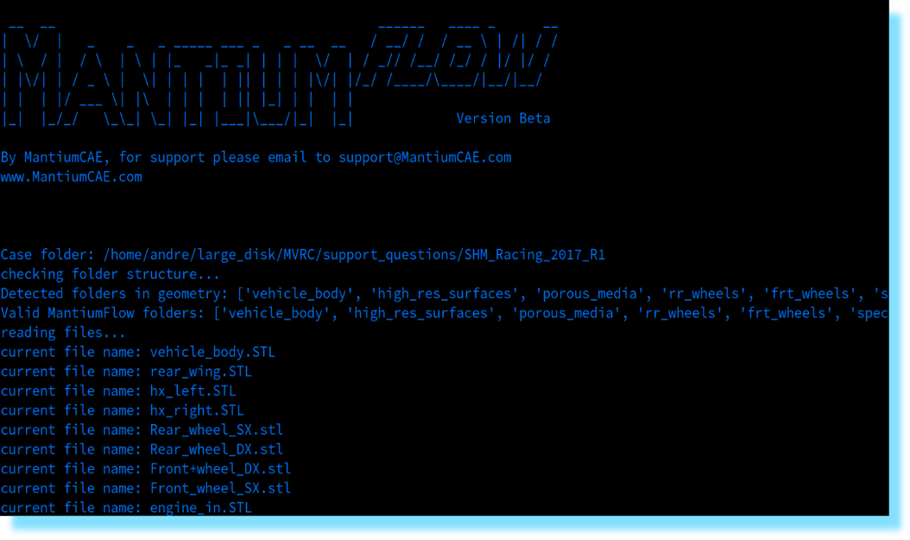*1st idea, CLI interface*

This idea consists of implementing a software in a command line interface run by the console or terminal of the device selected. It would manage the data by categories, and it would let the user manipulate attractions and select them by a graph

*2nd idea, GUI interface*

This idea consists of implementing a software in a graphical interface like most current applications. It would manage the data by categories, and it would let the user manipulate the filters and search specific characteristics.

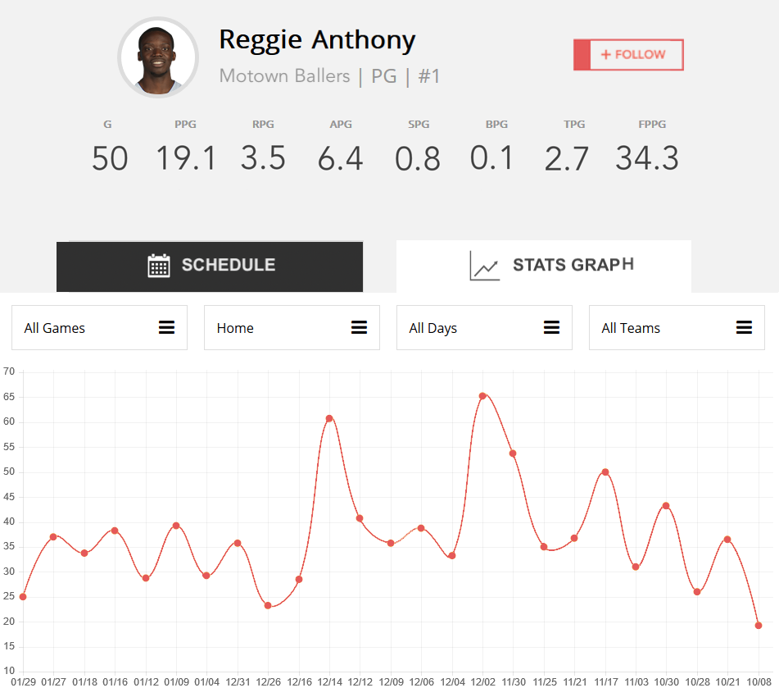*3rd idea, online interface*

This idea consists of implementing a software in an online data base with a user in a specific website, it would manage the data by categories, and it would let the user manipulate the attractions in live time to choose the route by a graph

.

**REPORTS AND SPECIFICATIONS**

The specification, design and require documents that the program needs to implement can be found in the docs folder of the Github repository where the project is stored.

**DESING IMPLEMENTATION**

The implementation can be founded in the Github repository. It’s made with java and javafx.

1. https://www.geeksforgeeks.org/generics-in-java/
2. https://blog.devmountain.com/what-is-github-and-how-do-you-use-it/
3. https://www.icesi.edu.co/moodle/pluginfile.php?file=%2F45665%2Fmod_resource%2Fcontent%2F1%2FArbolAVL.pdf
4. https://www.geeksforgeeks.org/graph-data-structure-and-algorithms/